Assignment: You have just won the Life Time Achievement Award for the great deeds and accomplishments you have achieved throughout your lifetime! Now it is time to accept your award! However, before accepting your award, one of your life long friends is going to write a speech, letting the audience know who you are, what your passions are, and what it is you have achieved in your life!

In this assignment you are going to pretend you are your friend (meaning you are going to write about yourself from the perspective of said friend – in third person). You are going to introduce yourself to the audience, go into detail about who you are and what makes you yourself, and what it is that you have accomplished throughout your life. Imagine that this is being written when you’re old and bald (like me!), so that means when your “friend” is going over achievements, you should be listing achievements that you hope to accomplish in your lifetime (keep it realistic, none of us are going to become an Avenger, but what is it you want to do in life?). Your speech should be one to two pages in length and by the end of the speech, the audience should have a clear understanding of who you are.

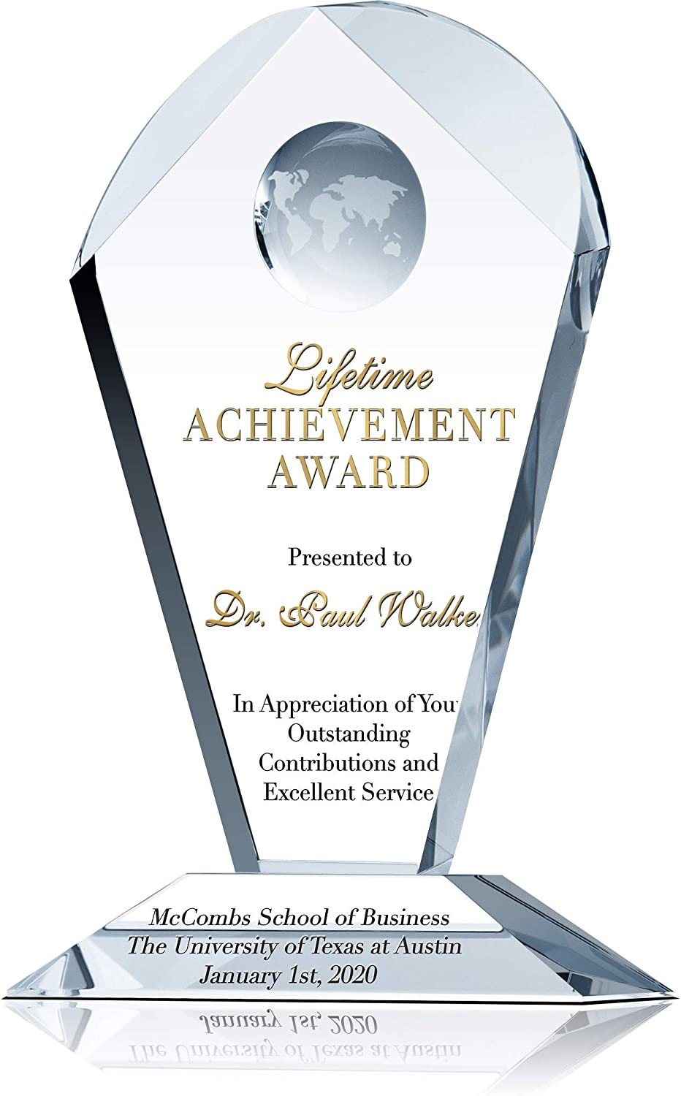

Life Time Achievement Award/Hall of Fame

CATEGORY | 5 pts.  Excellent | 3 pts.  Acceptable | 1 pts.  Needs Improvement
Criteria | - Includes the important details of one’s life  - Written from the perspective of a friend  - tells the whole story  - interesting to read – includes enthusiasm and detail goes in depth about the award winner | - Includes most of the important details of one’s life  - Written from a neutral perspective  - tells a story  - interesting to read – shows some detail but lacks depth | - Does not includes most of the important details of one’s life  - No perspective presented  - tells the partial story  - fails to show interest, enthusiasm, detail, or depth
Creativity | - Include pictures/graphics/stories  - Incorporates facts with the author’s own spin  - Presented in a unique manner | - Include some pictures/graphics/stories  - Incorporates some facts with the author’s own spin  - Presented in a normal manner | - No pictures/graphics/ or stories incorporates  - None or few facts with no spin  - Presented in a haphazard manner
Organization | - Stays on topic  - Follows logical progression  - Understandable | - Stays on topic  - Parts move out of order  - Can be somewhat unclear | - Goes off topic  - Is confusing, unclear, and/or illogical
Mechanics | 1 spelling, punctuation, grammar, and mechanics error. | 2 spelling, punctuation, grammar, and mechanics errors. | 3-4 spelling, punctuation, grammar, and mechanics errors.
Total Points _________ (20)

